Rechenzentrum - IT-Service/Support
Stand: 22.04.2024 – V15
If you need personal IT-service support @Campus Fulda, the IT-Center supports you as follows:
- All documents you find here, URL: doku.rz.hs-fulda.de
QR-Code to scan
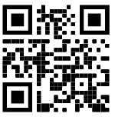
- You need individual help? Write an email to to: fdnr-support@rz.hs-fulda.de,
In email is required:
  - Contact details (last name, first name and telephone number)
  - Matriculation number/ FD-number (fd…)
  - Issue (when applicable error message or screenshots)
  - Indication – why documentation wasn't helpful
QR-Code to scan
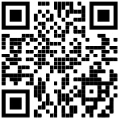
- You need personal support on Campus? You find us during the following service times:
- In the Student Service Center (SSC) building 10 @Infothek:
  - Monday: 09:00 - 14:30 Uhr
  - Tuesday: closed
  - Wednesday: 13:30 - 15:30 Uhr
  - Thursday: 08:30 - 09:50 Uhr
  - Friday: 09:00 - 12:00 Uhr

- You need help and can't make it during our service hours? Then write to
fdnr-support@rz.hs-fulda.de and arrange a meeting @Campus Fulda

- In order to minimize the risk of infection, we still recommend wearing a (FFP2) mask during personal contact.
